**Termwork 2**

NAME: XXX DATE: 01/05/2023

USN: 2GI20CSXXX

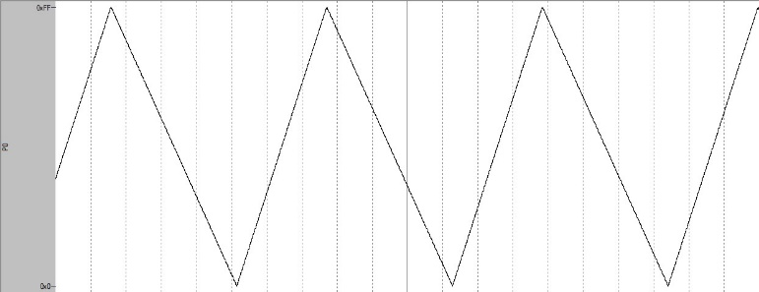 Triangle Wave

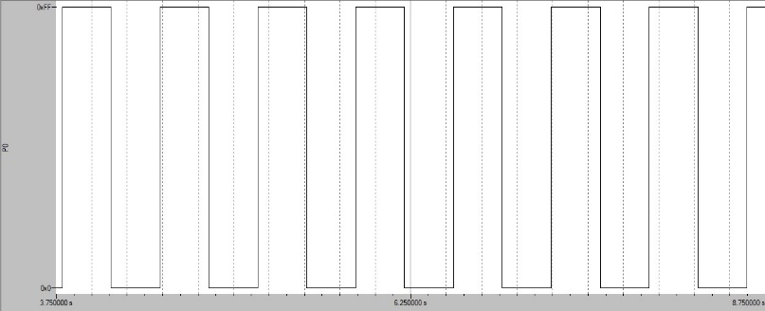 Square Wave (50% duty cycle)

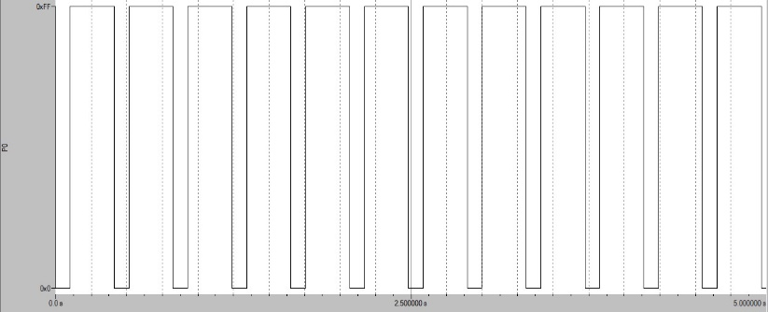 Rectangle Wave (75% duty cycle)

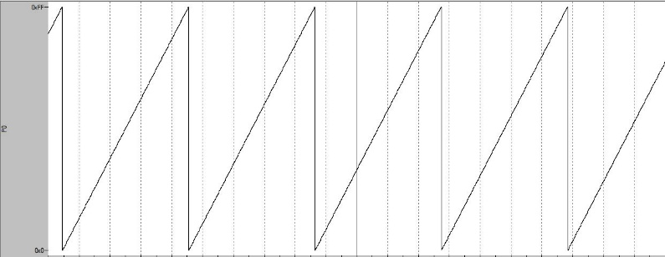 Saw Tooth Wave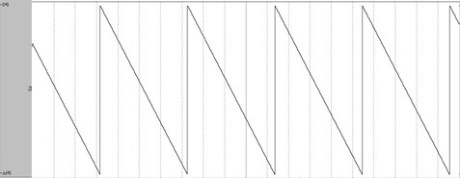 Saw Tooth Negative Wave